📘 CHAPTER 4: Arrays, Tuples & Object Typing in TypeScript

***1. Typing Arrays***

An array in TypeScript can be typed in two ways:

***Using type[] -***

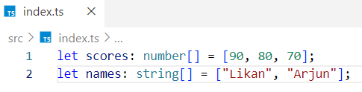

***Mixed Type Array (with union) -***



***Using Array<type> -***

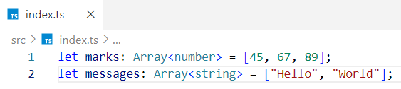

Both are valid. Pick one style and be consistent.

***Invalid example -***

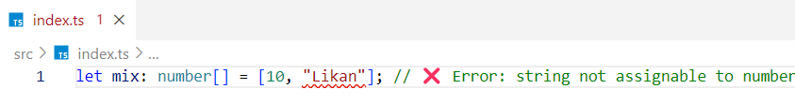***2. Typing Arrays of Objects***

Example:

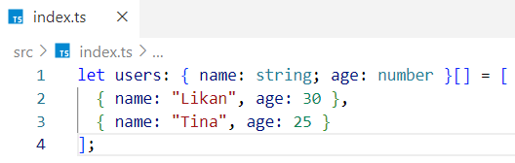

You can also use a type alias.

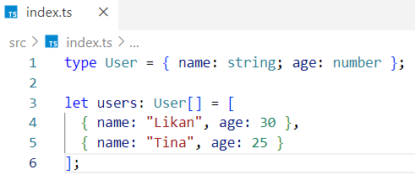

***3. What is a Tuple?***

A tuple is a fixed-length, fixed-type array.

Example -

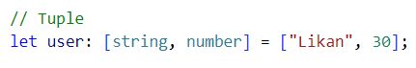

Only allowed:

* 2 elements
* First is string, second is number

❌ This will error

 

***Use cases:***

* Coordinate pairs: [number, number]
* HTTP response: [string, number]

***4. Typing Objects***

***Simple object:***

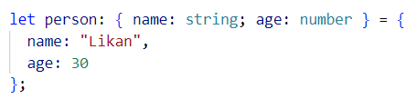

***Optional Properties***

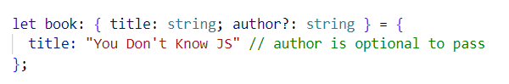

***Read-only Properties***

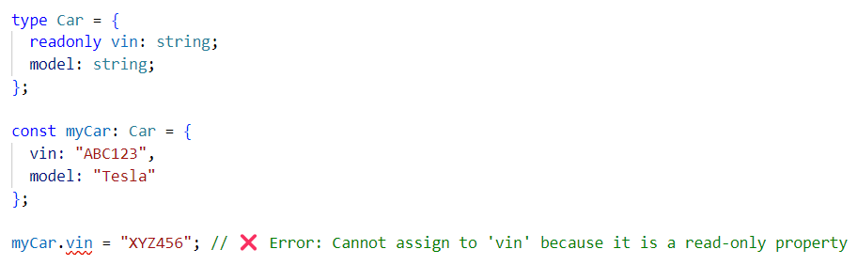

***5. Arrays vs Tuples vs Objects***

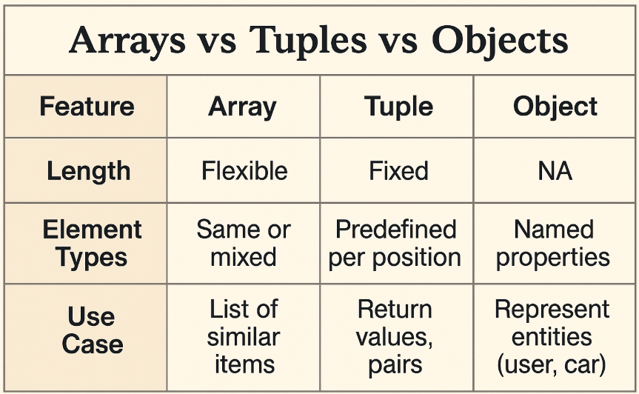

***Q: What’s the output?***

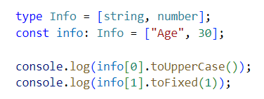

***Output:***

AGE

30.0

Interview Insights

***Q1: When to use a tuple over an object?***

Use a tuple when order matters and values are few (e.g., [latitude, longitude])

Use objects when values are descriptive or named

***Q2: Can arrays hold mixed types?***

Yes, but you must define it explicitly.



***Q3: What does readonly do for object properties?***

It makes the property immutable after creation.